PROJECT TITLE

NAME :ASHWIN KUMAR.A

REG NO;RA2111002010029

DEPARTMENT : MECHANICAL -A

SUBMITTED TO

DR. R. RAJKUMAR

DSBS

SCHOOL OF COMPUTING

SRMIST

JANUARY 2022

SALES MANAGEMENT SYSTEM

ABSRACT :

A sales management system is a platform that helps the sales team reach its goals. Sales managers can use this platform to track data, reduce admin tasks, and assign leads. Customer information can be stored on the platform, which helps streamline [sales and marketing collaboration](https://www.nutshell.com/blog/growth-team-sales-and-marketing-alignment/).

There are a variety of sales management system platforms available. Later in this post, we'll discuss the nine best options. You should consider which tools your sales team needs to succeed before deciding which platform is best for your company.

FLOW CHART :

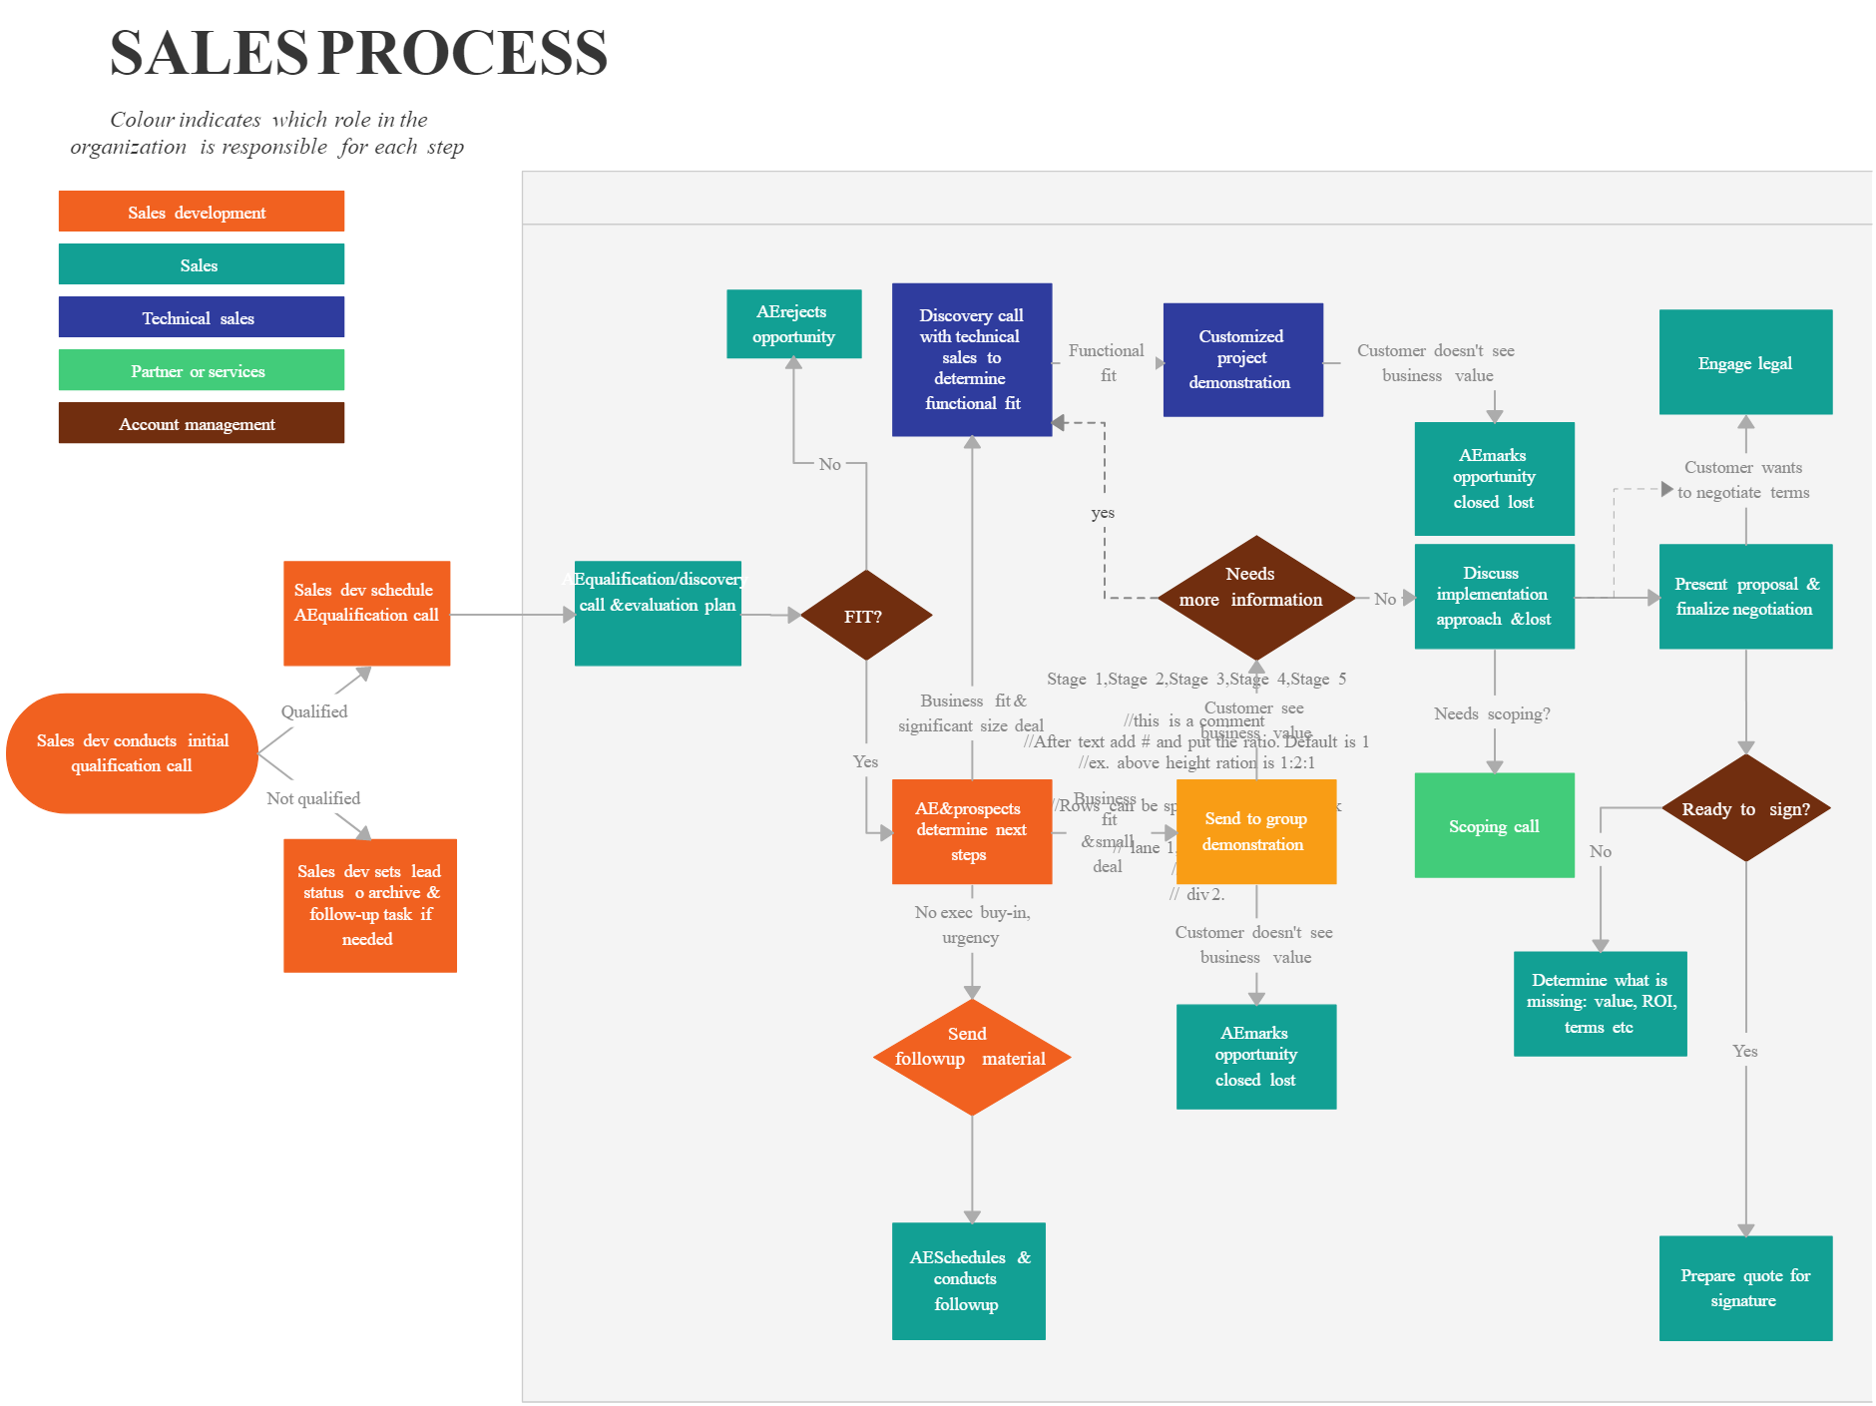

PROGRAM :

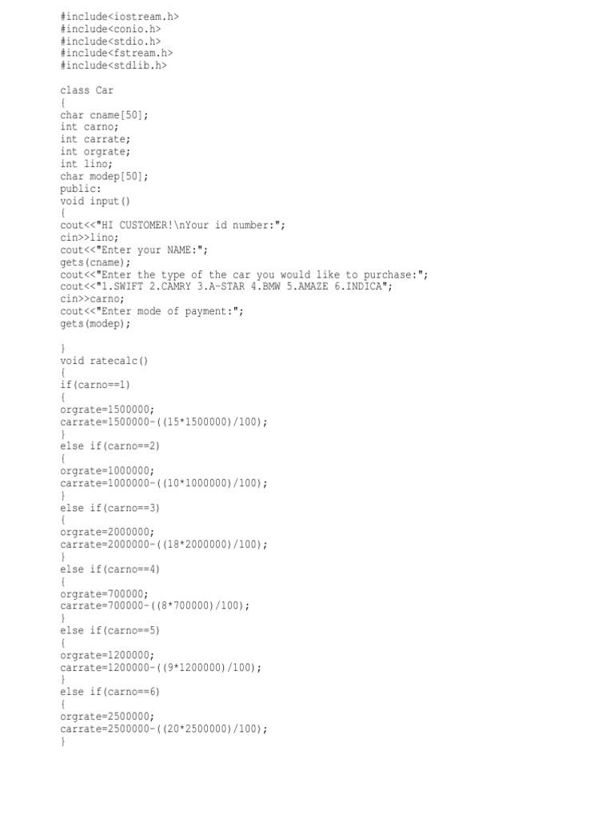

RESULTS :

The given program is verified as Sales Management System

SCREENSHOTS

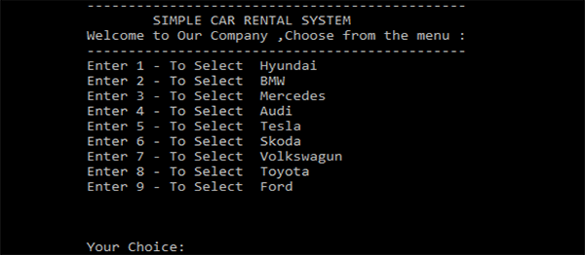

DECLARATION

Thanks you to all my friends and professors

RERERENCES :

https://www.nutshell.com/blog/best-sales-management-systems